# Armadillo Fact Sheet

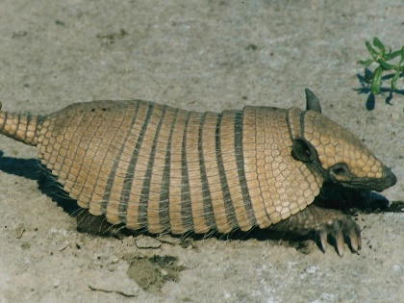 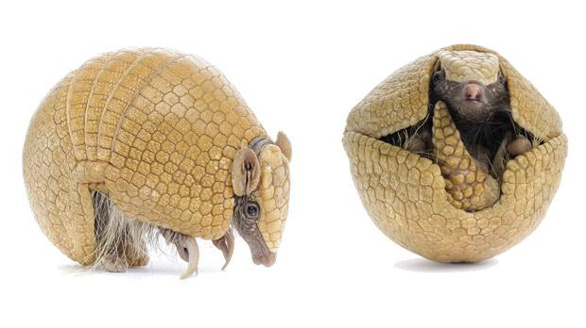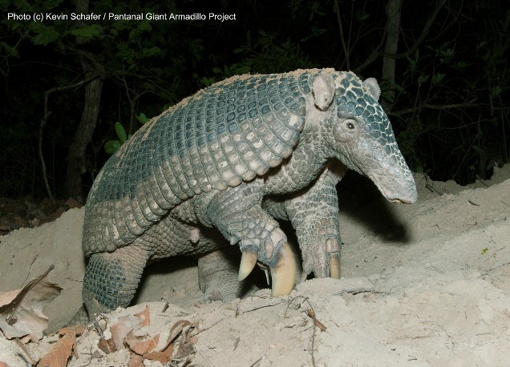

There are 20 species of armadillos in the Americas and five of those species can be found in Brazil. Two species in Brazil, three-banded armadillo (center) and the giant armadillo (center), are considered vulnerable species on the IUCN Red List (<http://www.iucnredlist.org/>). The six-banded armadillo (left), giant armadillo, or another burrowing species cause problems for Brazilian farmers.

## Mammalia

Despite their slightly reptilian look, armadillos are mammals and therefore warm blooded. They produce natural body heat and temperatures that are higher than the cool earth that they live in.

## Body

## Their armor is formed by [plates](https://en.wikipedia.org/wiki/Plate_(anatomy)) of [dermal bone](https://en.wikipedia.org/wiki/Dermal_bone) covered in relatively small, overlapping scales. Most species have rigid shields over the shoulders and hips, with bands separated by flexible skin covering the back and flanks. Additional armor covers the top of the head, the upper parts of the limbs, and the tail. The underside of the animal is never armored and is covered with soft skin and fur.

## Diet

Armadillos are omnivores. Their diet varies by species, but usually includes fruits, nuts, insects, grubs, and carrion (dead animals).

## Habitat

Armadillos live in many different habitats, ranging from grassland to rainforest, but are mainly found on open plains. Each armadillo requires about 230 acres of land or roughly 1/3 square miles of habitat.

## Digging

Armadillos are known for digging holes and underground dens while searching for food. Burrows can be large with openings up to 17 inches wide. The burrows are not typically deep and the limited soil depth above them may not support plant life. Armadillos are excellent diggers, and most can dig under physical barriers like tree roots, fences, and other obstructions. Three-banded armadillos dig for insects but do not dig their own burrows. They live in abandoned burrows or make their dens under dense vegetation.

## Senses

Due to their poor eyesight, armadillos rely on their sense of smell to detect prey and predators. Many species live most of their life underground and up to 70% of their sensory perception is olfactory (smell). They can also use pheromones to communicate with each other.